**Health**

Canadian Red Cross

The Canadian Red Cross mission is to improve the lives of vulnerable people by mobilizing the power of humanity in Canada and around the world.

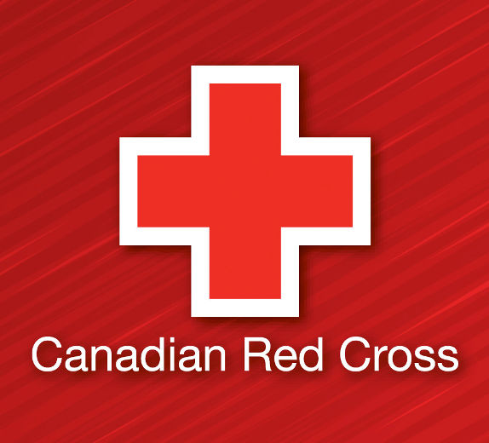

Alzheimer Society

The Alzheimer Society is the leading not-for-profit health organization working nationwide to improve the quality of life for Canadians affected by Alzheimer's disease and other dementias and advance the search for the cause and cure.

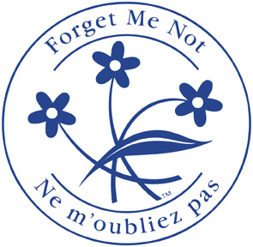

The Foundation of Fighting Blindness

The Foundation Fighting Blindness is leading the fight against blindness by advancing retinal disease research, education and public awareness.



American Foundation for Suicide Prevention

By educating the public, they change the way people think and talk about suicide and mental illness. By educating leaders and communities, they help to shape new laws and policies.



Breast Cancer Prevention Fund

The Breast Cancer Fund works to connect the dots between breast cancer and exposures to chemicals and radiation in our everyday environments.

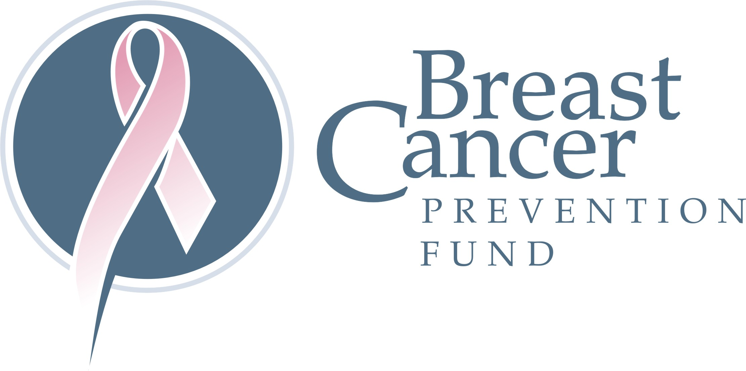

HopeHIV

We support children and young people in sub-Saharan Africa who have been orphaned or affected by HIV/AIDS. Rather than dismissing them as helpless victims, we believe they have the potential to lead change in their families, communities and countries and create a better future for Africa.

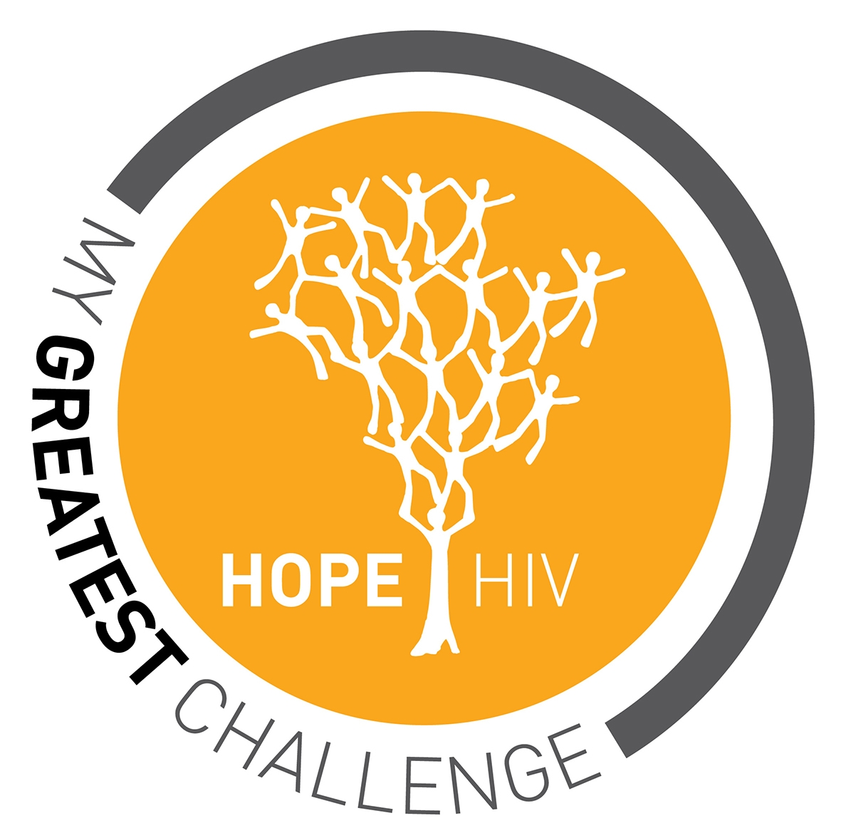

Against Malaria Foundation

We fund anti-malaria nets, specifically long-lasting insecticidal nets (LLINs), and work with distribution partners to ensure they are used. We track and report on net use and malaria case data.

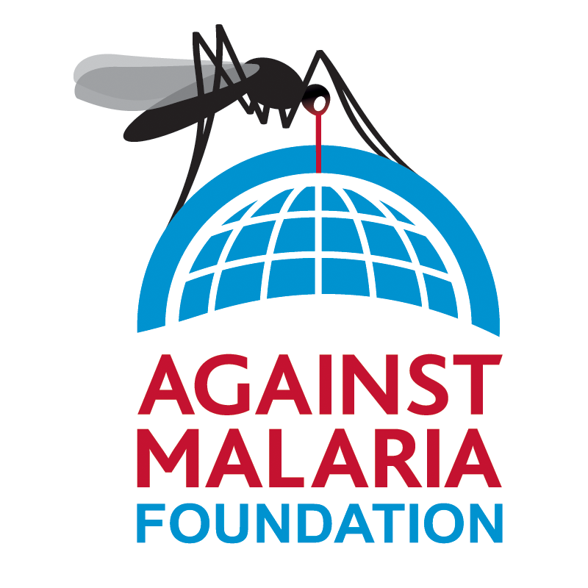

The Global Alliance or Improved Nutrition

Around 3.5 billion people — half the people on the planet today — are malnourished. Each year, malnutrition kills 3.1 million children under the age of five and leaves 161 million stunted, trapping generations in lives of poverty and unfulfilled potential. The Global Alliance for Improved Nutrition (GAIN) is focused on finding solutions to end malnutrition within our lifetimes.

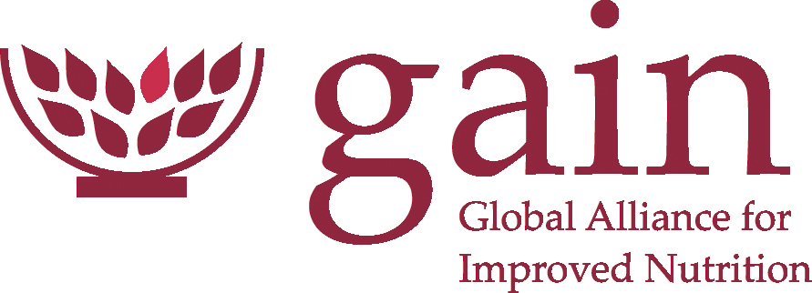

Deworm the World Initiative

Deworm the World, which supports government-led mass deworming in schools, and Dispensers for Safe Water, which provides chlorination services at rural water points to make water safe to drink, are excellent examples of the Evidence Action vision.

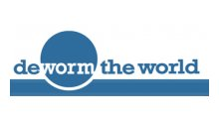

Action Against Hunger

Action Against Hunger saves the lives of severely malnourished children while helping vulnerable communities become self-sufficient.



**Education**

Education without Borders

Education without Borders (EwB) aims to provide improved educational opportunities and facilities in disadvantaged regions of the world.

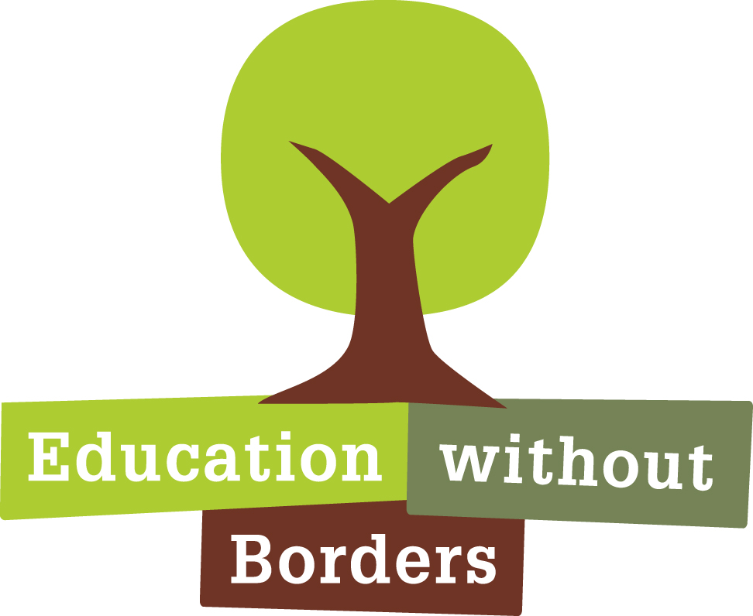

Rose Charities

We raise money, resources and personnel to support Rose Charities projects that have strong local leadership and dedicated volunteers in communities around the world. We work with them as they find their own solutions to the problems of poverty.

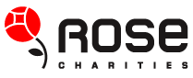

Teachers Across Borders

TAB brings master teachers from the U.S., Sweden, Australia and other countries to Cambodia and South Africa to help teachers who face enormous challenges including low pay, minimal facilities, class sizes of 75 or more, few materials and no teacher training.

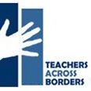

Africa Educational Trust

We are working for education for all in the face of conflict and poverty. Education is a right. It is also the most requested service, and key to helping communities move towards peace and prosperity.

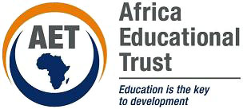

Canadian World Education Society

The Canadian World Education Society is a registered non­profit Canadian organization. We are committed to improving access and overcoming barriers to education in developing regions.

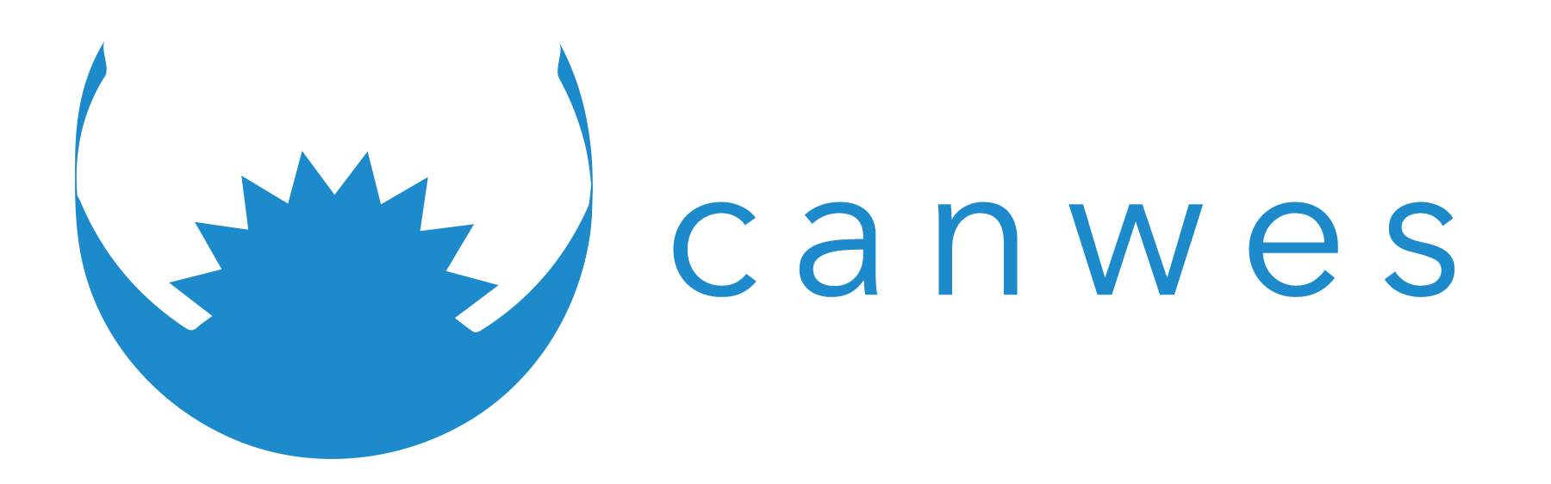

Mon Sheong Foundation

The Mon Sheong Foundation is a Canadian registered charitable organization, dedicated to the promotion of Chinese culture, heritage, language and philosophy through caring for the elderly, encouraging the young and providing programs and services to meet the needs of our communities.

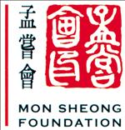

The Money Minding Foundation

Our Mission is to equip people and communities to achieve sustainable economies by providing tools, education and training with a new money paradigm that leads to increased financial capacity.



You Have It In You Foundation

Our mission is to love, protect and educate children, youth and women in vulnerable communities.

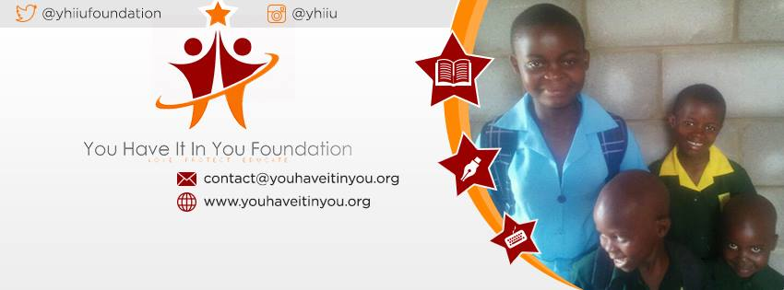

Atlantic Youth

Atlantic Youth is a Nova Scotia based agency providing innovative youth support options for schools, families, communities and government agencies all across Canada.

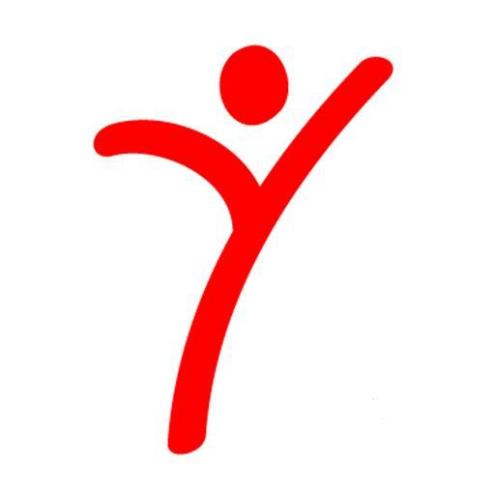

Pathways to Education

It works with high school students from low-income areas that have high dropout rates and helps them to transition into post-secondary education.

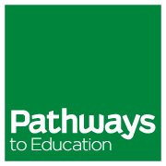

**Environment**

Union of Concerned Scientists

Our scientists and engineers develop and implement innovative, practical solutions to some of our planet’s most pressing problems—from combating global warming and developing sustainable ways to feed, power, and transport ourselves, to fighting misinformation and reducing the threat of nuclear war.

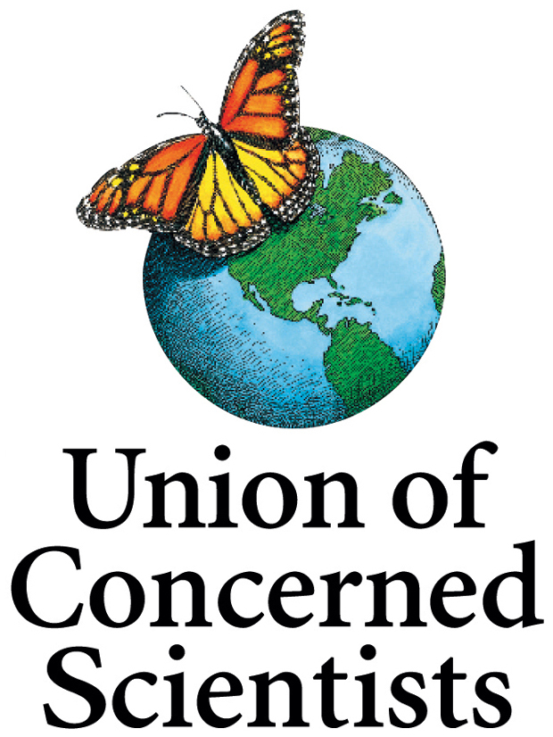

Natural Resources Defense Council

NRDC is the nation's most effective environmental action group, combining the grassroots power of more than 2 million members and online activists with the courtroom clout and expertise of nearly 500 lawyers, scientists and other professionals.

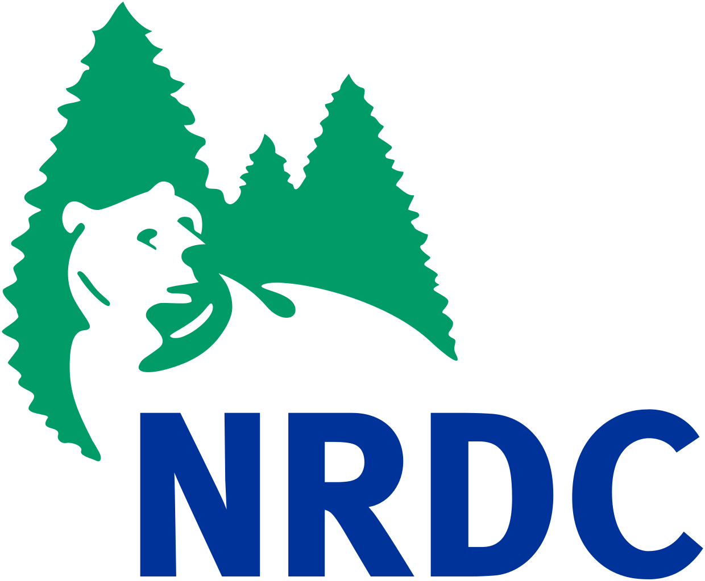

Environmental Working Group

The Environmental Working Group’s mission is to empower people to live healthier lives in a healthier environment. With breakthrough research and education, we drive consumer choice and civic action.



Friends of the Earth

We are members of Friends of the Earth International, a global network representing more than two million activists in 75 different countries. In the United States, we advocate in the halls of Congress, in state capitals, and with community groups around the country. With offices in Washington, D.C., and Berkeley, CA, and members in all 50 states, we urge policymakers to defend the environment and work towards a healthy environment for all people.

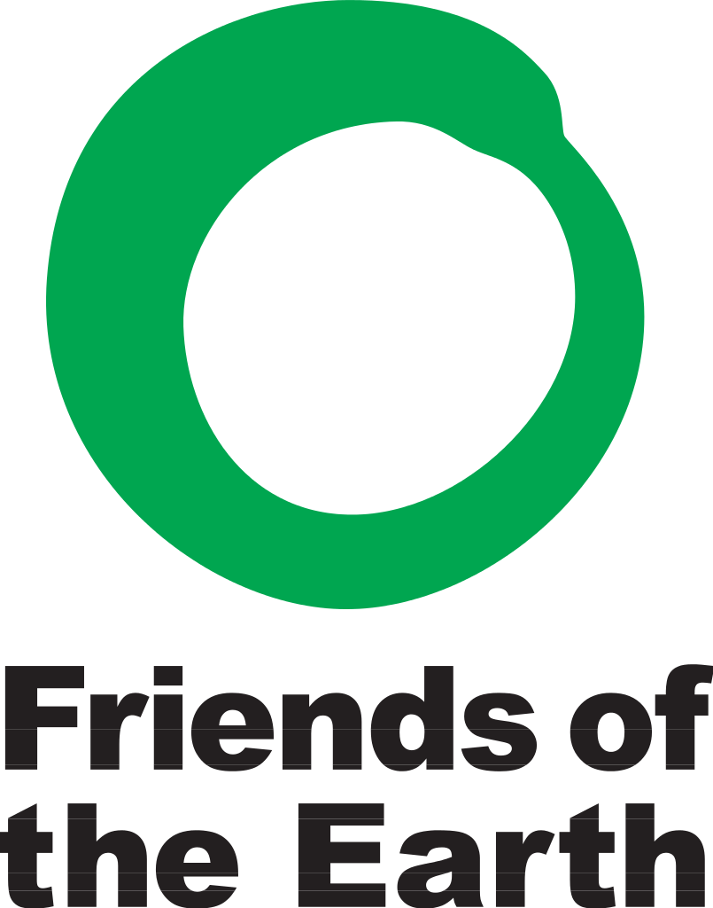

Rainforest Alliance

The Rainforest Alliance works to conserve biodiversity and ensure sustainable livelihoods by transforming land-use practices, business practices and consumer behavior.

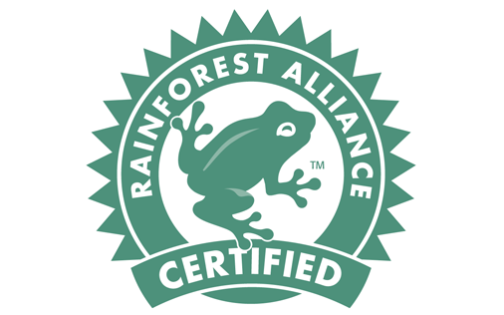

Earth Justice

Earth Justice uses the power of law and the strength of partnership to protect people’s health; to preserve magnificent places and wildlife; to advance clean energy; and to combat climate change.

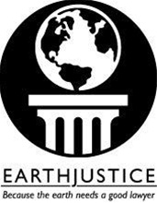

Ocean Conservancy

Ocean Conservancy seeks the best and brightest to help us achieve our goal of a healthy, thriving ocean.

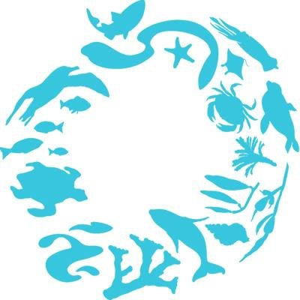

Earth Island Institute

Earth Island Institute is home to more than 60 grassroots projects working for environmental sustainability.

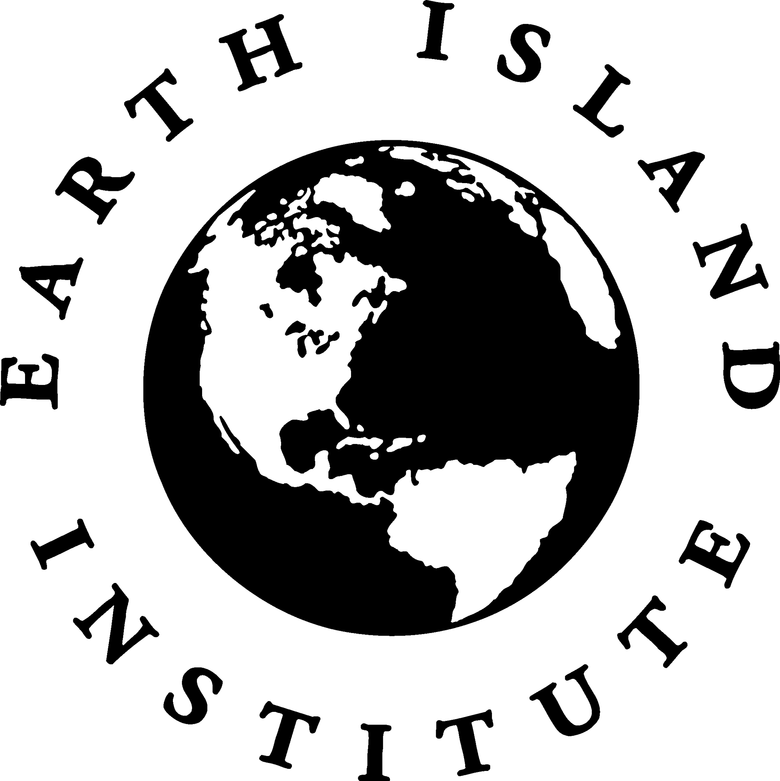

The Sierra Club Foundation

Our board and staff raise charitable funds, preserve and enhance these assets, and ensure they are used appropriately.  As the fiscal sponsor of the charitable programs of the Sierra Club, we provide resources to it and other nonprofit organizations to support scientific, educational, literary, organizing, advocacy, and legal programs that further our charitable goals.

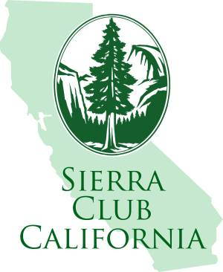

Amazon Conservation Association

Our mission is to protect the world's most diverse landscapes, train the next generation of Amazonian conservationists, and partner with communities to support livelihoods that sustain biodiversity.

